Gas Pipeline Rehabilitation

Gas distribution piping systems are a vital, but unseen part of energy distribution networks to consumers in all parts of the world.

Older piping systems tend to be cast iron and bare steel, with coated steel and polyethylene being more recent installations.

Many gas companies are faced with high activity, not in expanding their piping network, but in replacing older pipes.

Because cast iron and bare steel systems are older, they tend to be in the urban areas, where there is congestion and asphalt or concrete paving is covering the ground surface.

The cost of replacing or rehabilitating these pipes is extremely high, it is both expensive and difficult to cut new trenches in city streets. There has been a need for less disruptive methods to either replace or rehabilitated the pipe.

Renovation systems offer the following advantages over open-cut, or other types of trenching methods:
- Avoid locating a new pipe route in a congested area.
- Seal off, but do not destroy service connections
- Minimizes risk of damage to adjacent utilities and structures

Some problems with different replacement systems are:
- Difficulties in maintaining a gas supply to customers during the process.
- Sometimes a loss of pipe diameter, and thus gas flow volume
- Reconnection of gas service required

METHODS USED

The methods used to renovate gas piping can be divided into the following categories:
- Conventional insertion (sliplining) of polyethylene into the old pipe.
- Live (no gas interruption) insertion of polyethylene into old pipe.
- Modified sliplining, where there is tight polyethylene liner.
- Pipe splitting or bursting, with a PE liner installed
- Cured in place hose liner systems

Conventional Insertion of PE
A popular method of replacing older pipe has been to insert new polyethylene (PE) into older pipes, while increasing pressure to compensate for a smaller diameter. In the USA this is typically called “sliplining”.
Sliplining is one of the simplest and cheapest forms of renovation, and has been used in the gas industry for decades. The method can be used both on mains and services, and does not require special equipment.

The major drawback to sliplining is the loss of capacity from the smaller new pipe, thus the area where sliplining is most successful is where the pressure can also be increased to compensate for this loss in capacity.

For sliplining to be successful the old line must be relatively clean and free from obstructions. A general guideline is for the outside diameter of the new pipe to be 10% less than the inside diameter of the old pipe. The space between the old and new pipes is usually left open.

As with many renovation systems, the gas needs to be shut off and then reconnections made at the completion of the sliplining procedure.

Live Insertion of PE

A newer development in the sliplining of PE has been a method to accomplish the work without shutting off the gas supply. All illustrations show the Blackburn/Lyontec method, licensed and marketed by Steve Vick, and are from the Steve Vick literature.

Throughout the project, gas pressure is maintained to customers while transfers to new services can be accomplished at a controlled pace.

PE is inserted by use of a pushing machine through a special disposable gland box/valve that allows the work to proceed without loss of gas. The new PE already has a cap installed, so that higher pressure can be fed into the new PE, while maintaining the original pressure around the PE inside the old main.

Inserting the new main
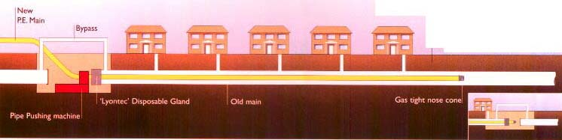

Preparing to Tie-in the PE
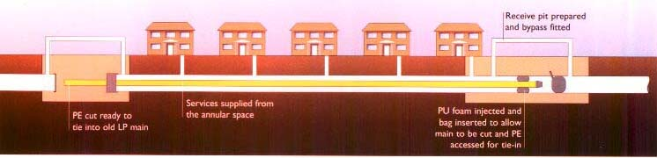

Transferring the Services
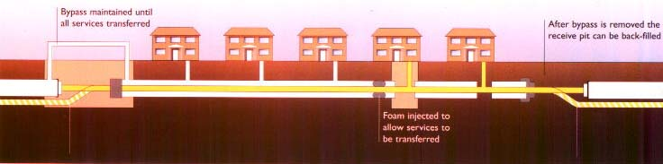

The old pipe can be accessed and foam inserted so that a piece can be removed and a new PE service can be attached to the new PE main. Eventually the end of the PE can be eventually connected to the existing system or new PE pipe.
Detail Views

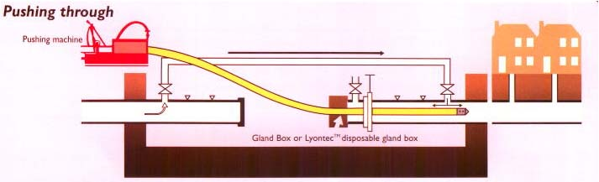

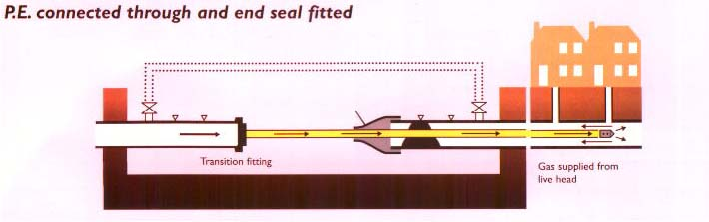

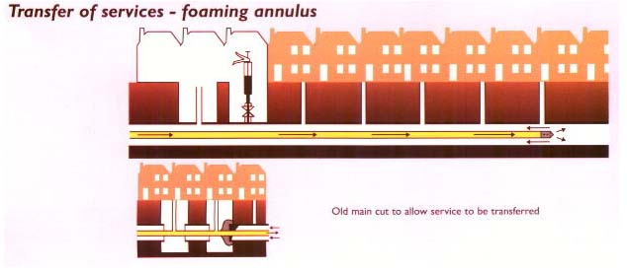

Modified Sliplining

Modified sliplining is the insertion of pipe by reducing its diameter, or folding the pipe to allow its installation inside an existing pipe. Once in place, the reduced or deformed pipe is returned to its original diameter, which forms a close fit to the existing pipe. This allows more cross sectional area, and thus more gas flow.
Like many other systems, these are processes performed when the gas is shut off.
First the existing pipe must be taken out of service and internally inspected (usually with a close circuit television camera). A camera will show if there are protruding fittings such as plugs, tees or valves that will need to be removed or reduced with a grinding wheel, so that the new PE pipe will fit through the old pipe with being scraped or gouged. If necessary the pipe can also be cleaned using wire brush or scraper pigs.
Prior to these tasks, sections of the PE pipe would be fused together, the fusion bead removed, and the pipe moved into position.

Rolldown
Rolldown is a technique developed in the UK in the mid-1980’s. In the rolldown process, a hydraulically operated pushing machine forces the PE through multiple pairs of rollers to reduce its diameter by up to 20%. The process is conducted at ambient temperatures for PE pipe of 4” to 24” diameter (SDR 11 through SDR 42)

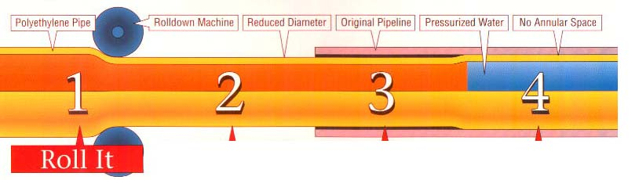

- The pipe diameter is first reduced by passing through a series of rollers.
- A pipe that has been reduced will hold its new diameter for up to 24 hours, but can be reverted back sooner by pressurizing with air immediately.
- As a result of the new smaller diameter the pipe can be inserted easily into the old pipe. For larger diameters or longer lengths, a winch can be used to pull the PE through the old pipe.
- Either hydrostatic pressure or higher-pressure air can be used to revert the PE back to its original diameter.

Services are connected to the PE in the same manner as in normal pipe insertion techniques.

Deformed Liners

Deformed liners are those PE pipes manufactured in a “U” shape, which reduces the cross sectional area by 55%. The deformed liner can be transported in a coil to the work site ready to be uncoiled and inserted. Since it has smaller profile, it can be inserted easily into the old pipe.

A cable is inserted through the old pipe and the deformed pipe is pulled through. When completed, steam is injected into the pipe, which causes it to unfold. This process takes from 1 to 4 hours, depending on the diameter and length of the pipe. Diameters up to 24” can be accommodated using this process.

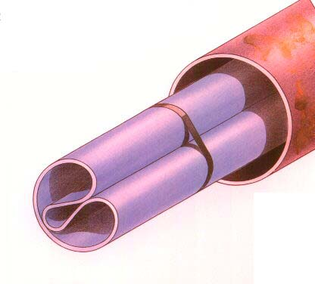

Deformed Pipe Lining

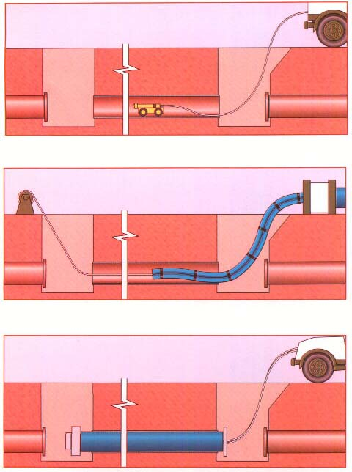

CAMERA INSPECTION AND THEN PULLING THE PE PIPE
RE-SHAPING THE PIPE

Pipe Splitting or Bursting

Pipe Splitting
Older steel pipes (and some ductile iron pipes) can be replaced by a continuous splitting method that pulls a PE liner with it. It is possible to replace size-for-size and also to upsize with this method.

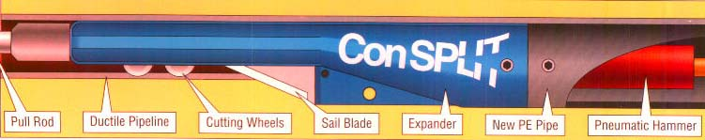

The splitting tool is launched into the old pipe at an entry pit and pulled through to an exit pit. The old pipe is split open and expanded and expanded out into the soil, allowing the PE pipe liner to be pulled behind into the enlarged hole immediately behind the splitting tool. As the tool moves through the pipe the wheel initially cut into the pipe wall interior, the blade then completes the split and expands open the pipe. The gas-carrying pipe is inserted into the PE liner. This method has been used on both mains and services.

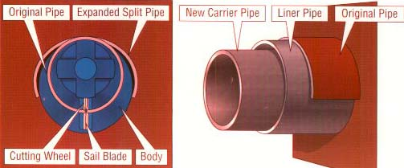

Pipe Bursting
Cast Iron can be burst and a liner inserted as the pipe is burst. A bursting head is winched through the pipe. The burst head can be pneumatic (pulsating air pressure dives the head forward and bursts the pipe); or hydraulic (the head expands hydraulically as it is pulled through bursting the pipe and any joints or fittings) The hydraulic head is most commonly used for cast iron gas pipe.
There can be an expander used behind the bursting head, so that a pipe larger than the original can be installed.

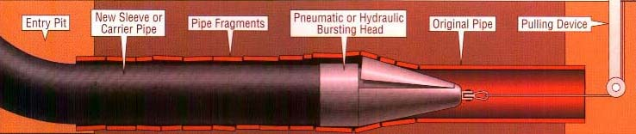

It is sometimes necessary to install a sleeve with the burst head, so that pipe fragments do not damage the new polyethylene pipe. Once the casing sleeve is installed, the PE pipe is inserted into the sleeve. In Europe, coated polyethylene is now available, with tough polypropylene outer coating, so that the gas pipe can follow the burst head and the coating protects the PE.

Cured-in-Place Liners
The cured-in-place method is the insertion of a flexible lining into the existing pipe, using an inversion installation process. The lining is a woven synthetic fiber covered with a polyester elastomer as the lining material. The liner is impregnated with resin or polyurethane, to bond to the inside of the old pipe.
The pipe is first taken out of service and a camera inserted to check for intrusions from service tees or other fittings. Next the pipe is cleaned using wire brushes or movable sandblast equipment. The liner is coated inside with the bonding material. The end of the liner are turned inside out and fasted to the pipe. Next the outside is pressurized with air, forcing the liner to turn inside out as it moves down the pipe. This forces the coated surface next to the old pipe inside wall. The liner is left to cure, or it can be cured quicker by introducing steam inside the liner.

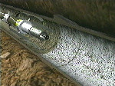 Sandblasting the pipe
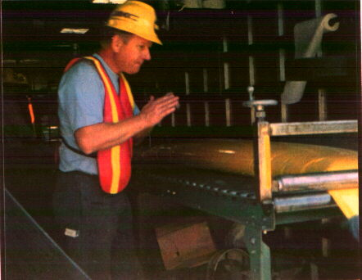 Placing the epoxy inside the pipe

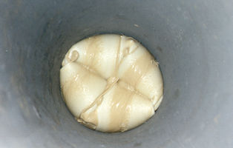 the liner inverting as it moves down the pipe

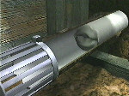 the liner moving down the pipe

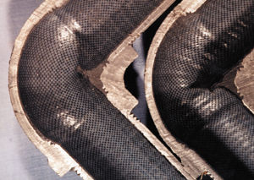 cured in place liners can travel around 90º bends

A big advantage of cured in place liners is that they can travel around bends in the pipe up to 90º in the pipe. This method can be used for lining mains and services.

New small excavation and maintenance operations

Although small excavations using small size openings and vacuum excavation have been used for some time, there has been a renewed attention given to it as gas companies try to minimize the cutting of asphalt or concrete streets.

Development approaches have focussed on three areas:
- Cutting the street
- Vacuum excavation equipment
- Specialized tools to perform maintenance operations

1. Cutting the street
In order that vacuum excavation can be as small as possible, the opening in the street must also be small. Companies are using small excavations by normal jackhammer methods, normally 18” x 18” or 24” x 24” square openings. More recently companies are using a large core drill that can be mounted on the bed of a small truck. The core drill cuts out a circular (normally 18” diameter) piece of the street, which can be removed and then replaced after the work is finished. Water is carried on the vehicle to assist in cutting. After replacing the core, the outside edge is sealed using epoxy.

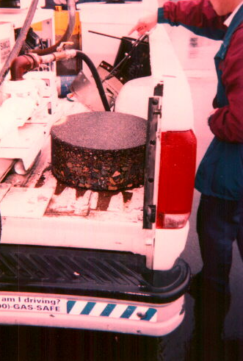
Core drill truck, showing a core that was cut out

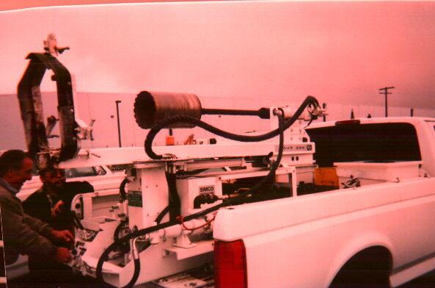
Core truck showing core drill

2. Vacuum Excavation Equipment
Items included in vacuum excavation equipment are the mounted vacuum blower, the equipment to handle the soil, and vacuum hoses. It may also include water storage and water delivery, where water assisted excavation is used.
Personal preferences will dictate what type of unit is ordered. Individual needs such as congested work area, type of soils encountered, ability to handle soil excavated, whether equipment is mounted on a truck or a trailer.

Two main types of vacuum equipment are made.
One type uses a dump hopper that drops the soil out on site as excavated.
(see picture below)

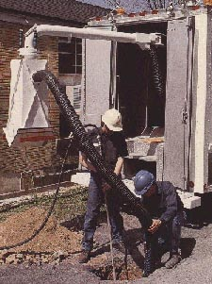The dump hopper can be seen in the background

A second type of system is where the soil is kept in tanks on the truck for dumping later (perhaps back at the company yard) An illustration is shown below.

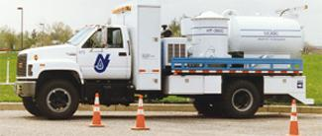

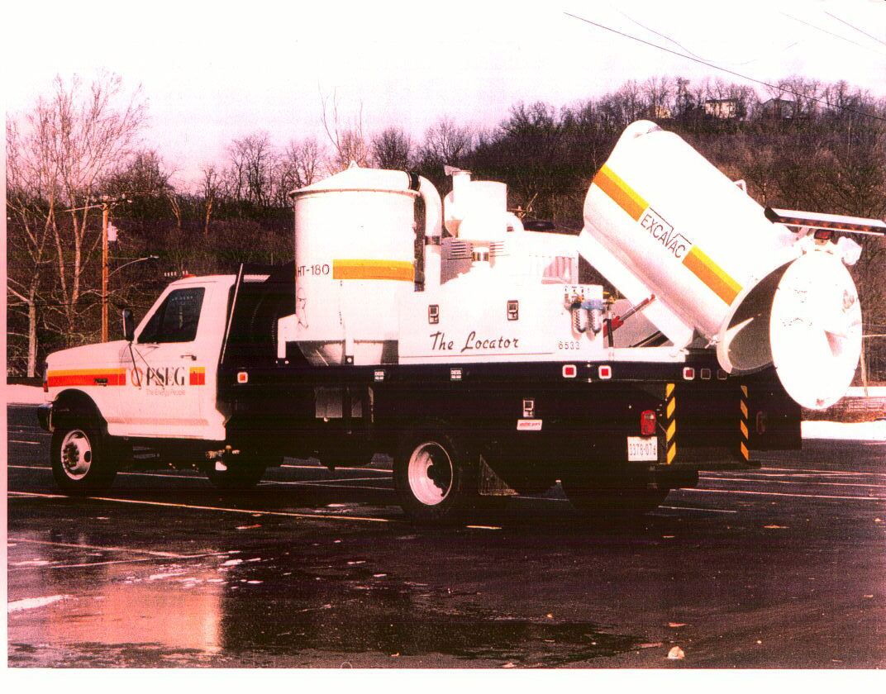

The equipment may also be mounted on a trailer or a pickup truck.
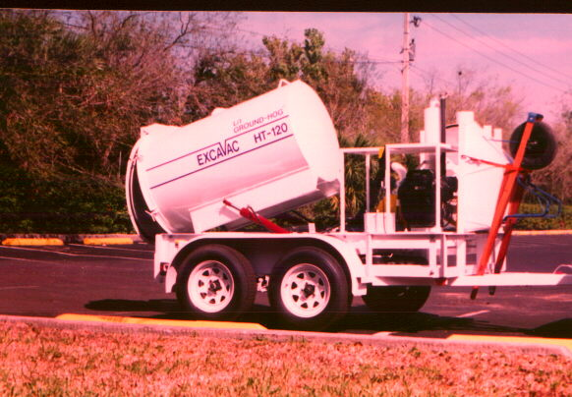

Most companies use 4: hoses approximately 25ft in length, but longer lengths have been used successfully.

Some vacuum equipment specifications used in the USA
COMPANY | SUPPLIER | COMPRESSOR | AIR FLOW | VACUUM “hg
PSE&G | Excavac | Diesel/80hp | 1,200cfm | 15”
Enbridge | Filtration Eng | Varies: PTO or 80hp on-deck | 780-1200 | 15”
SoCal | Pacific Tek | Diesel/37hp | 825cfm | 15”
BU | Filtration Eng | See above | See above | See above
Keystone Services | Own/ | Diesel/78hp | 700cfm | 10”
Miller | Own/ | Diesel/55hp | 920cfm | 14”
Wisconsin Gas | Fabrication Eng | See above | See above | See above

Tools

The tools used in keyhole excavation vary (logically) with the operation being performed. It is in the area of tasks to be performed (and therefore tools) that most potential is seen for expanded development.

Typical Operations performed are:
- Soil loosening and excavation
- Leak repair by encapsulation or anaerobic injection
- Cathodic protection activities, anode installation, test leads and boxes, etc
- Service abandonment, plastic and steel, low pressure and elevated pressure
- Mains abandonment and sealing
- Valve box clean out and repair
- Potholing (utility test holes for locating, etc.)
- Specialty uses- PE service tee cap replacement, abandoning mains, installing guardrails.
- Removal of drill mud or water

While development work is focussing on the current O&M activity entry tools, such as camera inspection launch, it has also started to address the issue of construction activities, especially new and replacement PE servicelines.

Some Examples of Specific Tools
- Excavation: Air Spade, air lance, water jet
- Corrosion Control: Wire Brush/Grinding Wheel, Cadweld probe
- Leak repair Drill probe, longer mold clamp/pliers, special molds
- Specialty: Service tee cap removal and repair (SoCal)
Foam injection (Enbridge)
- Service Abandonment: Squeeze-off probe, cutting shears (pe), cutting saw
(steel),

Photographs of some specific tools are shown below

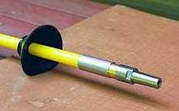 air spade nozzle

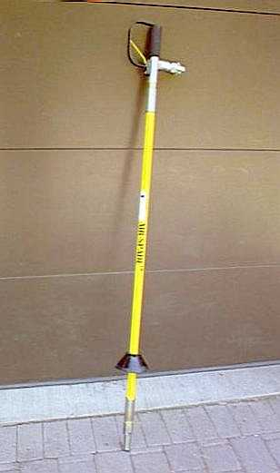 air spade

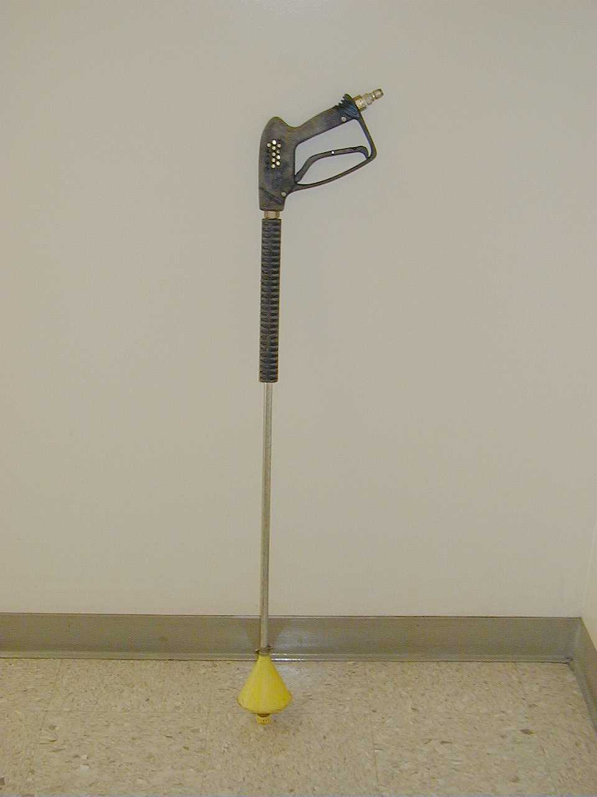 Water jet unit

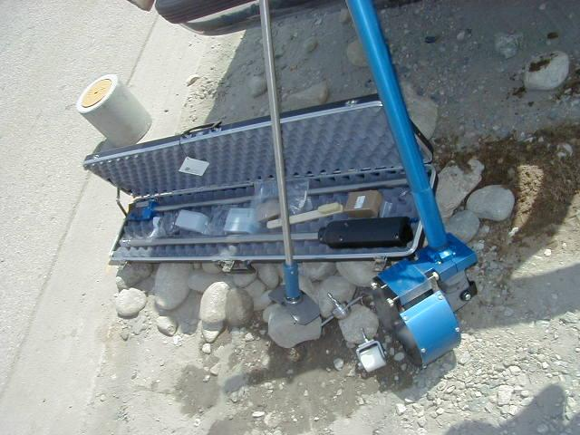
TOOLS FOR INSTALLING CATHODIC PROTECTION
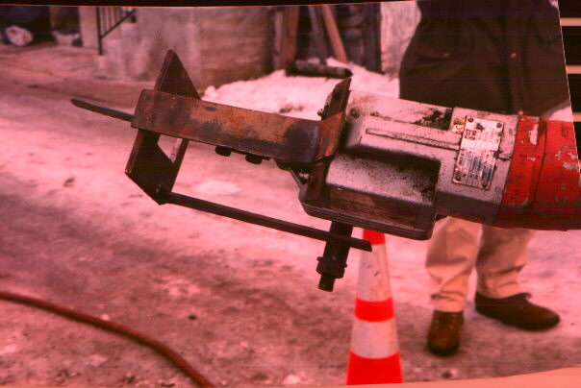
SAW for cutting a steel service from above the excavation

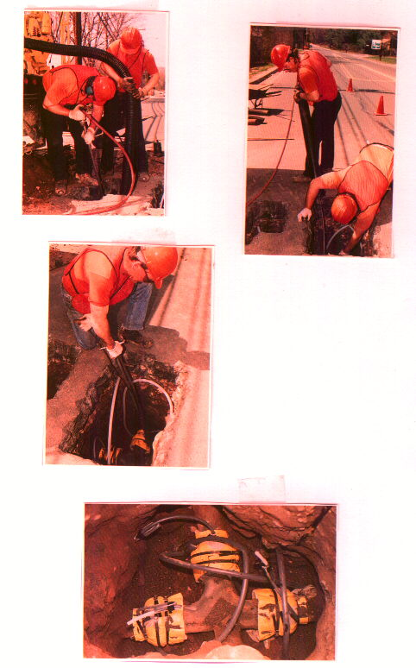
Repairing leaks from a keyhole excavation

